Module 7 csv execution in command prompt screenshot:

Provide the input filename

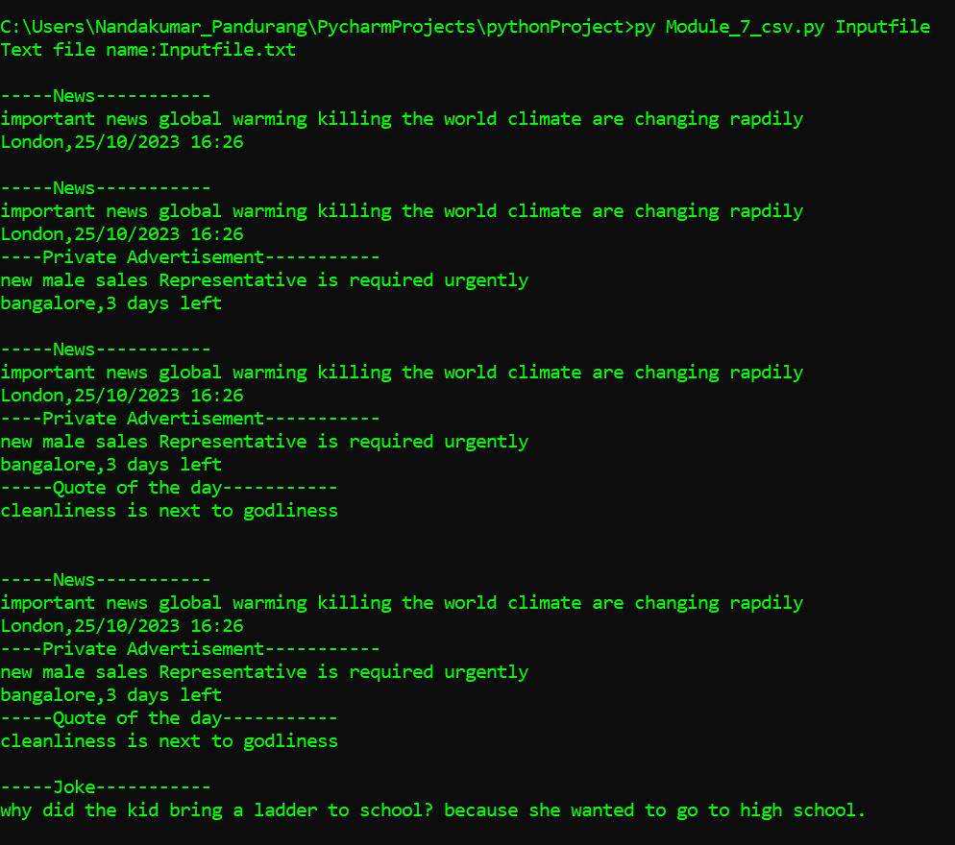

Provide the target file name followed by csv file names for 2 output.

